**Answer to Objective Questions:**

**1. What is the distribution of account balances across different regions?  
Ans:** The distribution of account balances across different regions is below:

| **Region** | **Account balance** |
| --- | --- |
| France | 311332479.5 |
| Spain | 153123552 |
| Germany | 300402861.4 |

**2. Identify the top 5 customers with the highest Estimated Salary in the last quarter of the year. (SQL)**  
Ans. **Select   
 CustomerId, Surname, EstimatedSalary from customerinfo   
 where  
 substring (`Bank DOJ`, 4, 2) in (10, 11, 12)   
 order by   
 EstimatedSalary desc  
 limit 5;**

|  |  |  |
| --- | --- | --- |
| **CustomerId** | **Surname** | **Estimated Salary** |
| 15634359 | Dyer | 199970.7 |
| 15804211 | Oluchukwu | 199841.3 |
| 15687913 | Mai | 199805.6 |
| 15599792 | Dimauro | 199638.6 |
| 15800620 | Fitzgerald | 199635.9 |

**3. Calculate the average number of products used by customers who have a credit card. (SQL)  
Ans.** The average number of products used by the customers who have a credit card is approximately **1.53**.

**SQL query:**

**Select   
 round (Avg (NumOfProducts), 2) as avg_product  
from   
 bank_churn  
where  
 HasCrCard = 1;**

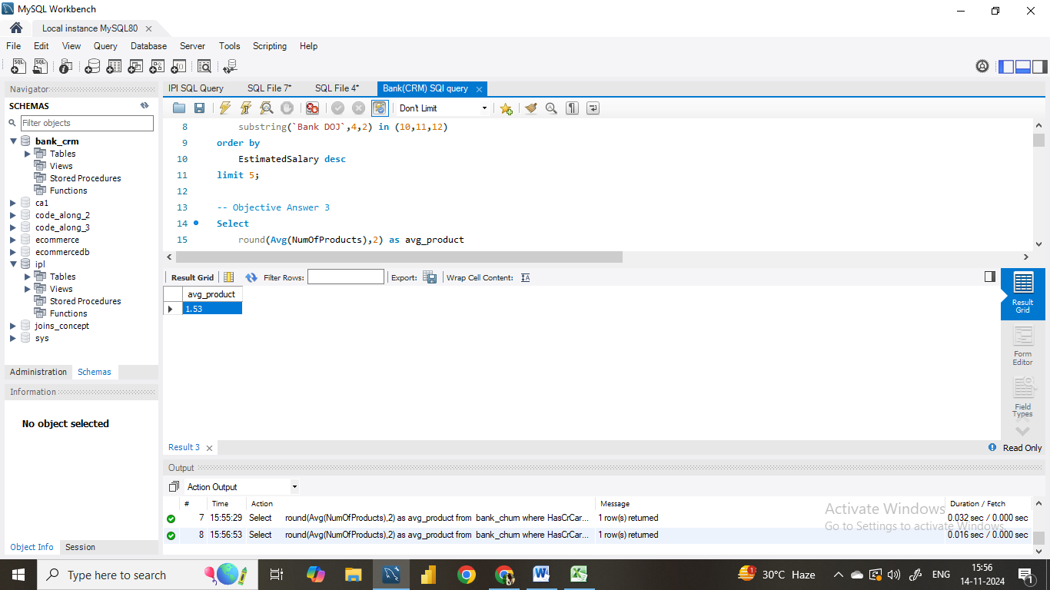

**4. Determine the churn rate by gender for the most recent year in the dataset.  
Ans.**  For the most recent year i.e., 2019 the churn rate for male category is 15.37 whereas for female category the churn rate is 25.05.

**Approach:** For this we have created a measure named Exit rate where we used the following formula:

Exit Rate = Divide (calculate (count('Bank_Churn'[CustomerId]), Bank_Churn[Exited] =1)*100 , count(Bank_Churn[CustomerId]))

This will calculate the Exit rate in percentage. Then we used the KPI card and applied the slicer of year with the most recent year and gender with male and female.

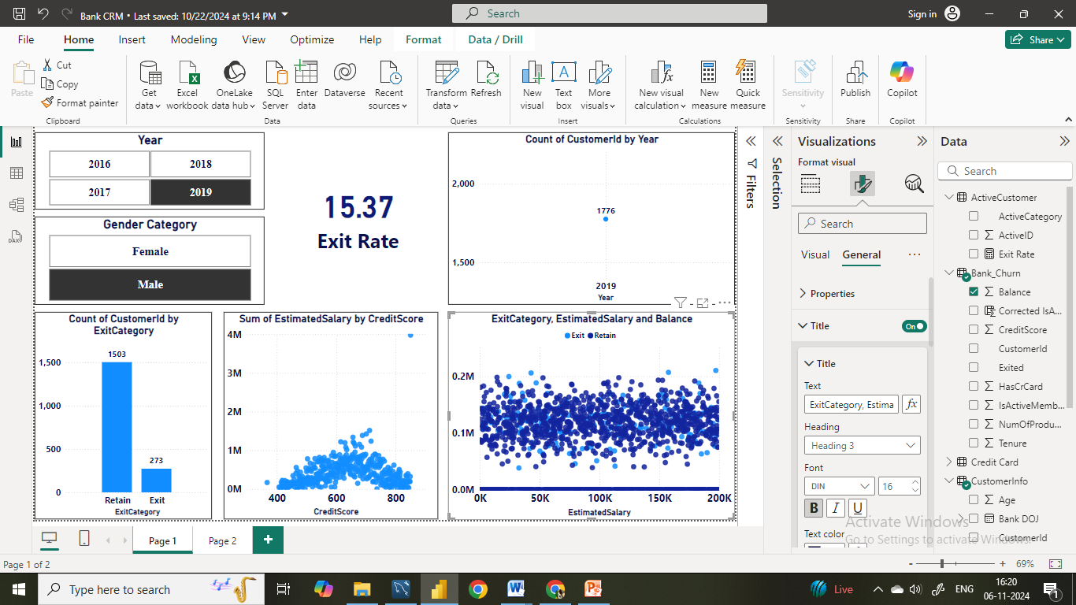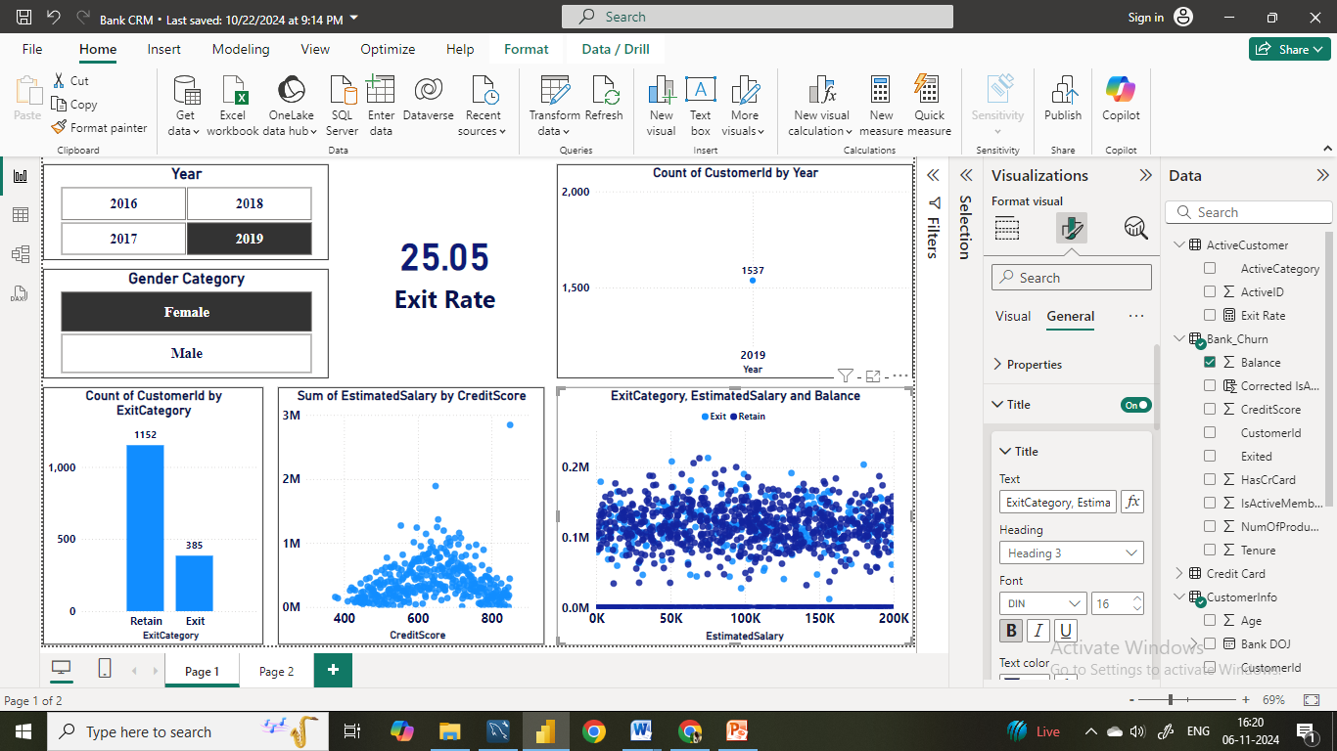

**5. Compare the average credit score of customers who have exited and those who remain. (SQL)  
Ans.**

**SELECT**

**AVG(case when Exited =1 then creditScore end) as exited_cr_score,**

**AVG(case when Exited =0 then creditScore end) as remain_cr_score**

**FROM**

**bank_churn**

**6. Which gender has a higher average estimated salary, and how does it relate to the number of active accounts? (SQL)  
Ans.** Here we can see that the average estimated salary of female is approximately 1,00,601 while for male it is approximately 99,664. Despite the slightly higher average salary for females, males tend to have more active accounts.

|  |  |  |
| --- | --- | --- |
| **Gender** | **AvgEstimatedSalary** | **Active_Member** |
| Female | 100601.54 | 2284 |
| Male | 99664.58 | 2867 |

**7. Segment the customers based on their credit score and identify the segment with the highest exit rate. (SQL)  
Ans.** Here we have segmented the customers on the basis of their credit score as “Good”, ”Fair”, ”Low” and “Very Low”. We can observe that the customer who have a good credit score are exiting frequently as compared to the customer who have a low and very low credit score.

|  |  |
| --- | --- |
| **Credit score segments** | **exit_rate** |
| Excellent | 128 |
| Very Good | 252 |
| Good | 452 |
| Fair | 685 |
| Poor | 520 |

**SQL Query:**  
**select**

**case when creditscore <= 579 then "Poor"**

**when creditscore between 580 and 669 then "Fair"**

**when creditscore between 670 and 739 then "Good"**

**when creditscore between 740 and 799 then "Very Good"**

**when creditscore>=800 then "Excellent"**

**end as `credit score segments`,**

**count(case when exited =1 then customerid end) as exit_rate**

**from**

**bank_churn**

**group by**

**`credit score segments`**

**order by**

**exit_rate desc;**

**8. Find out which geographic region has the highest number of active customers with a tenure greater than 5 years. (SQL)  
Ans.** From the below table we can see thatthe France has more number of active customers with a tenure greater than 5 years as compared to other region such Spain and Germany.

|  |  |
| --- | --- |
| **Region** | **ActiveCustomers** |
| France | 797 |
| Spain | 431 |
| Germany | 399 |

**SQL Query:**  
**Select GeographyLocation as Region, count(case when IsActiveMember = 1 then c.CustomerId end) as ActiveCustomers**

**from bank_churn b**

**join customerinfo c on b.CustomerId=c.CustomerId**

**join geography g on c.GeographyID=g.GeographyID**

**where Tenure>5**

**group by region;**

**9. What is the impact of having a credit card on customer churn, based on the available data?  
Ans.  
 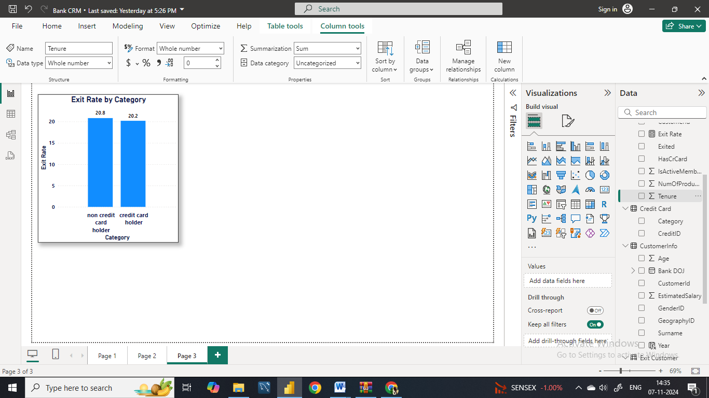  
Conclusion:** Based on the available data we can see a higher churn rate of customers who do not have credit cards compared to those who have credit cards. We can say that non credit card holders highly impact the churn rate.

**10. For customers who have exited, what is the most common number of products they have used?  
Ans.** It is clear from the data below that most common product used by customer who have exited is 1 with exit rate of 1,409.

|  |  |
| --- | --- |
| **NumOfProducts** | **Exited_Customer** |
| 1 | 1409 |
| 2 | 348 |
| 3 | 220 |
| 4 | 60 |

**11. Examine the trend of customers joining over time and identify any seasonal patterns (yearly or monthly). Prepare the data through SQL and then visualize it.**  
**Ans  
SQL Query :**  
**Select**

**right(`Bank DOJ` ,4) as Year,**

**count(customerid) as no_of_customer_joined**

**from**

**customerinfo**

**group by**

**Year**

**order by**

**Year;**

|  |  |
| --- | --- |
| **Year** | **no_of_customer_joined** |
| 2016 | 1951 |
| 2017 | 2143 |
| 2018 | 2593 |
| 2019 | 3313 |

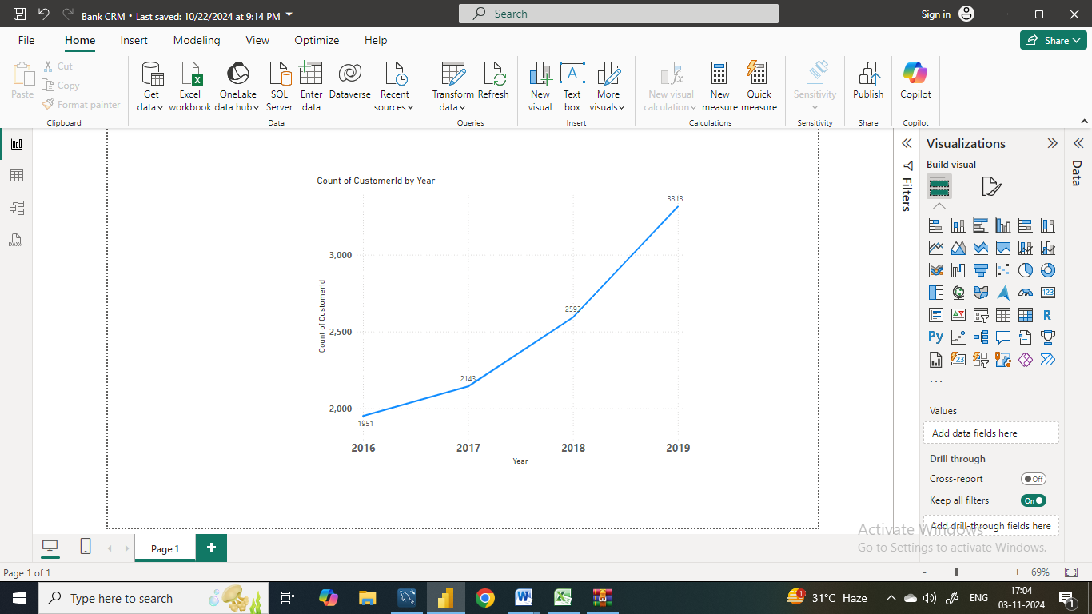

**Conclusion:** We can observe that every year the number of new customers has grown significantly which shows a positive growth trend. Particulary, we can see a notable spike from 2018 to 2019. In 2019 almost 700 customers have joined as compared from the previous year.

**12. Analyze the relationship between the number of products and the account balance for customers who have exited.**

**SQL Query:  
select**

**NumOfProducts,**

**round(Avg(Balance),2) as avg_account_balance,**

**Count(*) as customer_exited**

**From**

**bank_churn**

**where**

**Exited = 1**

**group by**

**NumOfProducts**

**order by**

**NumOfProducts ;**

|  |  |  |  |
| --- | --- | --- | --- |
| **NumOfProducts** | **avg_account_balance** | **customer_exited** | |
| 1 | 92028.82 | 1409 |  | |
| 2 | 90252.36 | 348 |  | |
| 3 | 85853.09 | 220 |  | |
| 4 | 93733.14 | 60 |  | |

**Conclusion:**

* We see that in the overall trend as the number of products increases, the account balance slightly fluctuates with balances generally decreasing until a spike at four products.
* Also, we can see that the customers three product have the lowest account balance which indicates that the customers who have more products are either consolidating or spending more before exiting.

**13. Identify any potential outliers in terms of balance among customers who have remained with the bank.  
Ans. Outlier Detection**: You can observe the points that fall significantly above or below the general "cloud" of data. These points may represent customers with unusually high or low balances relative to their estimated salary.

**Data Density**: The chart shows a dense clustering of points around the middle, with some scatter at the top and bottom edges, which might indicate potential outliers. 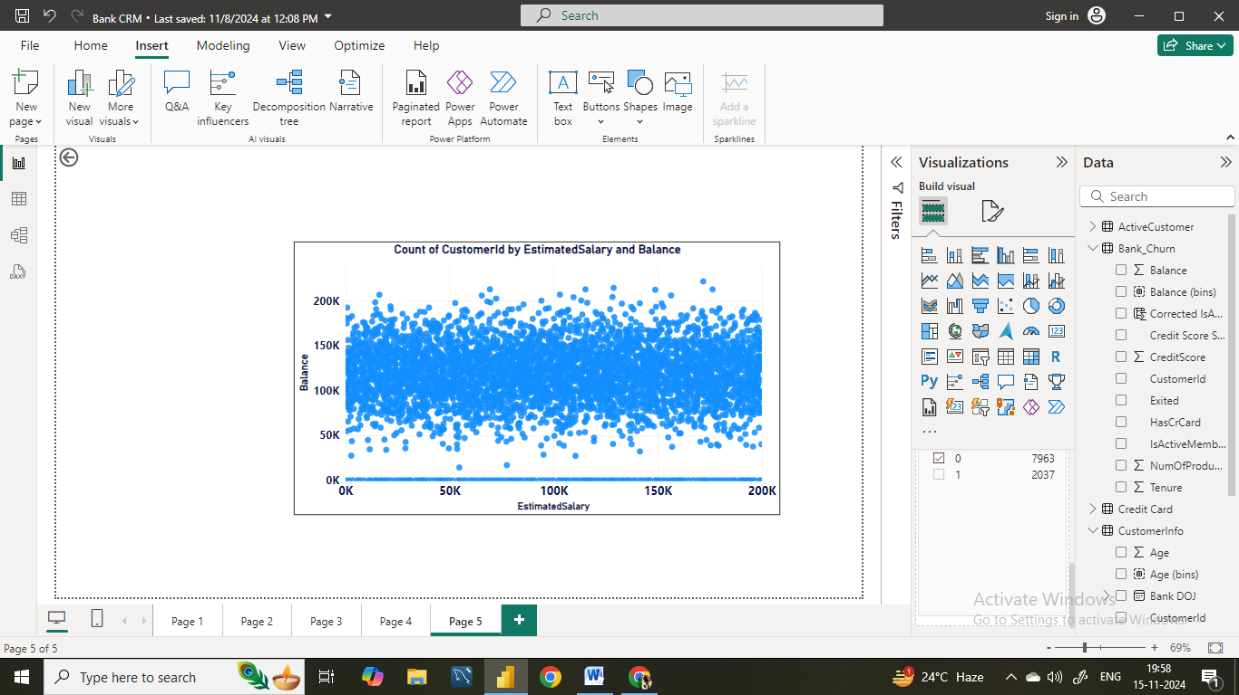 **Conclusion:** Our analysis is based on the potential outliers in terms of balance among customers who have remained with the bank. For this we analysed the distribution of account balances and estimated salary and applied a filter of active members who have not exited where we have found few significant outliers for the customers who usually have low or balance compared to the average balance.   
 This shows that there are customers who have specific financial behaviour, the reason of which should be understood so that the bank can build the strategies in order to meet the needs of diverse customer groups which in turn enhance the overall banks financial stability and the increases the customer satisfaction.

**14. How many different tables are given in the dataset, out of these tables which table only consists of categorical variables?  
Ans.** We Have Seven Different tables i.e., ActiveCustomer, Bank_Churn, CreditCard, CustomerInfo,

ExitCustomer, Gender, Geography.

Tables with Categorical Variables:

* CustomerInfo: Contains categorical variables like Surname.
* ExitCustomer: Contains categorical variables like Exit Category(Exit ,Retain).
* Gender: Contains categorical variables like Gender Category (Male,Female).
* Geography: Contains categorical variables like Geography Location (France, Spain,Germany).
* CreditCard: Contains categorical variables like Category (Credit-card holder , Non-Credit card holder)
* ActiveCustomer: Contains categorical variables like Active Category (Active Member , Inactive

Member).

**15. Using SQL, write a query to find out the gender-wise average income of males and females in each geography id. Also, rank the gender according to the average value. (SQL)**

**SQL Query:**

**select**

**GeographyID,**

**GenderCategory as Gender,**

**round(avg(EstimatedSalary),2) as avg_income,**

**rank() over(partition by GeographyID order by avg(EstimatedSalary) desc) as gender_rank**

**from**

**customerinfo c**

**join**

**gender g on c.GenderID=g.GenderID**

**group by**

**GeographyID,Gender;**

|  |  |  |  |
| --- | --- | --- | --- |
| **GeographyID** | **Gender** | **avg_income** | **gender_rank** |
| 1 | Male | 100174.25 | 1 |
| 1 | Female | 99564.25 | 2 |
| 2 | Female | 100734.11 | 1 |
| 2 | Male | 98425.69 | 2 |
| 3 | Female | 102446.42 | 1 |
| 3 | Male | 99905.03 | 2 |

**16. Using SQL, write a query to find out the average tenure of the people who have exited in each age bracket (18-30, 30-50, 50+).  
SQL Query:**  
**select**

**case when Age between 18 and 30 then "18-30"**

**when Age between 30 and 50 then "30-50"**

**when Age>50 then "50+"**

**end as `Age brackets`,**

**Avg(Tenure) as avg_tenure**

**from**

**customerinfo c**

**join**

**bank_churn b on c.CustomerID=b.CustomerID**

**where Exited = 1**

**group by**

**`Age brackets`**

|  |  |
| --- | --- |
| **Age brackets** | **avg_tenure** |
| 30-50 | 4.8899 |
| 18-30 | 4.777 |
| 50+ | 4.833 |

**17. Is there any direct correlation between salary and the balance of the customers? And is it different for people who have exited or not?  
Ans.** No, there is not any direct correlation found between the salary and balance of the customers.

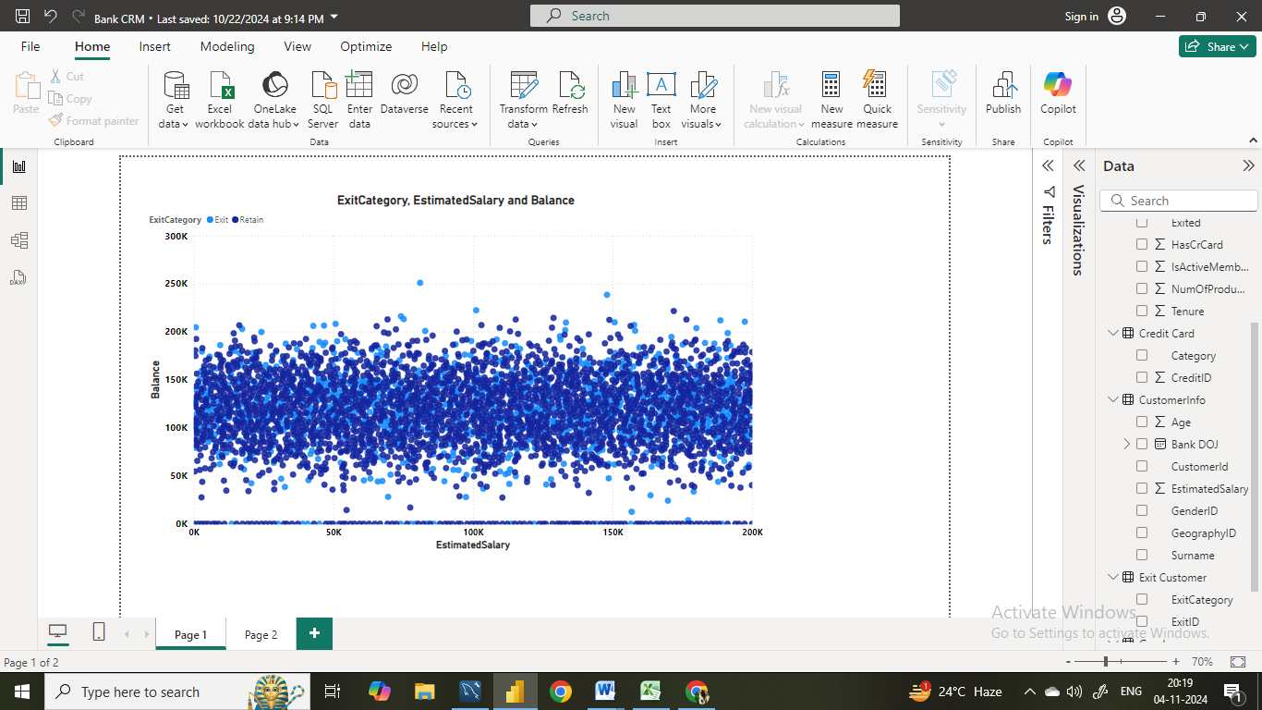

**18. Is there any correlation between the salary and the Credit score of customers?  
Ans.**  There is no such correlation found between the salary and the credit score of the customers. The credit score alone can’t be determined by salary.

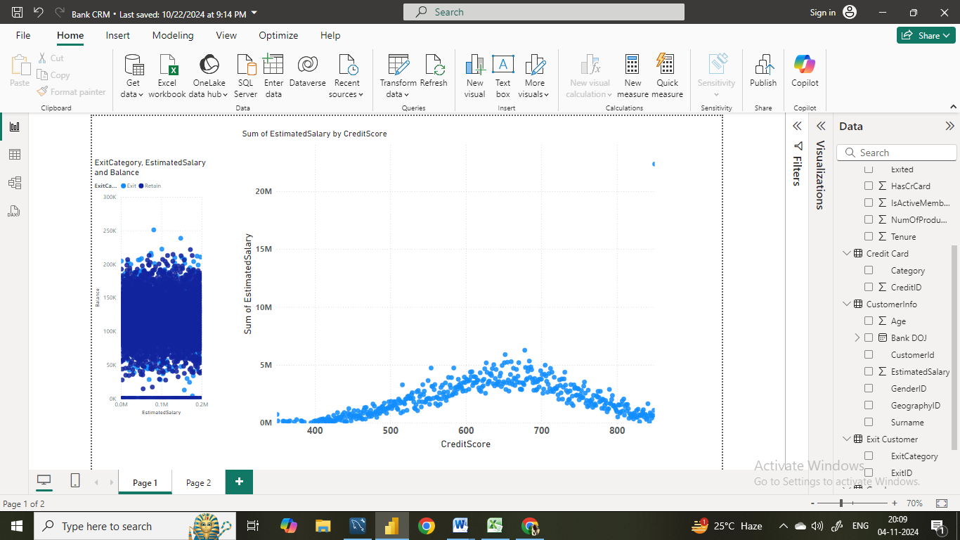

**19. Rank each bucket of credit score as per the number of customers who have churned the bank.  
SQL Query:**

**select**

**case when creditscore <= 579 then "Poor"**

**when creditscore between 580 and 669 then "Fair"**

**when creditscore between 670 and 739 then "Good"**

**when creditscore between 740 and 799 then "Very Good"**

**when creditscore>=800 then "Excellent"**

**end as `credit score bucket`,**

**count(case when exited =1 then customerid end) as exit_rate,**

**dense_rank() over(order by count(case when exited =1 then customerid end) desc) as `bucket rank`**

**from**

**bank_churn**

**group by**

**`credit score bucket`;**

|  |  |  |
| --- | --- | --- |
| **credit score bucket** | **exit_rate** | **bucket rank** |
| Fair | 685 | 1 |
| Poor | 520 | 2 |
| Good | 452 | 3 |
| Very Good | 252 | 4 |
| Excellent | 128 | 5 |

**20. According to the age buckets find the number of customers who have a credit card. Also retrieve those buckets that have lesser than average number of credit cards per bucket.  
SQL Query:**

**with cardinfo as (select**

**case when Age between 18 and 30 then "Adult"**

**when Age between 30 and 50 then "Middle-Aged"**

**when Age>50 then "Old-Aged"**

**end as `Age bucket`,**

**count(HasCrCard) as HasCreditCard**

**from**

**customerinfo c**

**join**

**bank_churn b on c.CustomerId=b.CustomerId**

**where HasCrCard= 1**

**group by 1)**

**select * from cardinfo**

**where HasCreditCard< (select avg(HasCreditCard) from cardinfo);**

|  |  |
| --- | --- |
| **Age bucket** | **HasCreditCard** |
| Adult | 1400 |
| Old-Aged | 874 |

**21.  Rank the Locations as per the number of people who have churned the bank and average balance of the customers.  
SQL Query:  
Select**

**GeographyLocation as Location,**

**Avg(Balance) as avg_balance,**

**count(case when Exited=1 then customerId end) as churned_cx,**

**dense_rank() over(order by count(case when Exited=1 then customerId end) desc) as `ChurnRank`,**

**dense_rank() over ( order by avg(balance) desc )as balance_rank**

**from**

**bank_churn**

**join**

**customerinfo using(CustomerId)**

**join**

**geography using(GeographyID)**

**group by**

**Location;**

|  |  |  |  |  |
| --- | --- | --- | --- | --- |
| **Location** | **avg_balance** | **churned_cx** | **ChurnRank** | **balance_rank** |
| Germany | 119730.1 | 814 | 1 | 1 |
| France | 62092.64 | 810 | 2 | 2 |
| Spain | 61818.15 | 413 | 3 | 3 |

**22. As we can see that the “CustomerInfo” table has the CustomerID and Surname, now if we have to join it with a table where the primary key is also a combination of CustomerID and Surname, come up with a column where the format is “CustomerID_Surname”.  
SQL Query:**  
**select c.CustomerId, Surname,Concat(c.CustomerId,"_",c.Surname) as customerid_surname**

**from customerinfo c**

**join bank_churn b on c.CustomerId=b.CustomerId;**

|  |  |  |
| --- | --- | --- |
| **CustomerId** | **Surname** | **customerid_surname** |
| 15634602 | Hargrave | 15634602_Hargrave |
| 15647311 | Hill | 15647311_Hill |
| 15619304 | Onio | 15619304_Onio |
| 15701354 | Boni | 15701354_Boni |
| 15737888 | Mitchell | 15737888_Mitchell |

**23. Without using “Join”, can we get the “ExitCategory” from ExitCustomers table to Bank_Churn table? If yes do this using SQL.  
Sql Query:**  
**Select *,**

**case when Exited = 1 then 'Exit' else 'Retain' end as exit_category**

**from**

**bank_churn;**

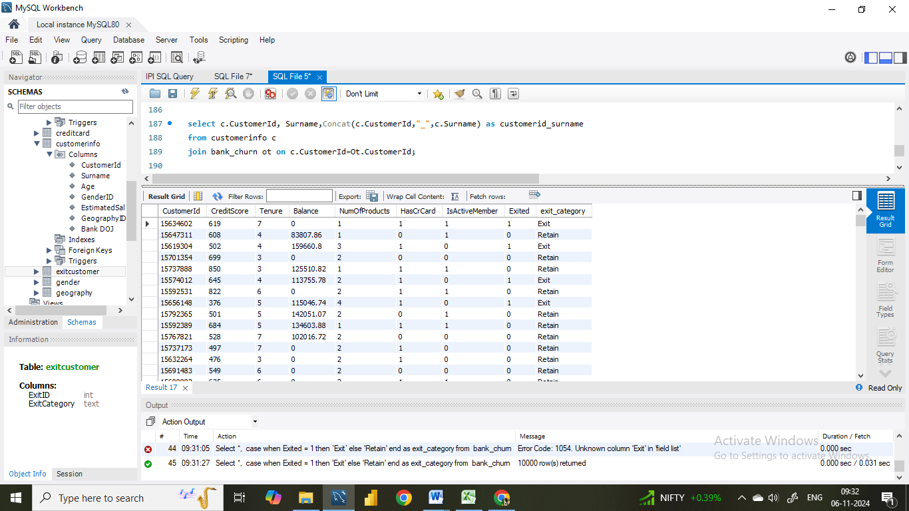

**24. Were there any missing values in the data, using which tool did you replace them and what are the ways to handle them?  
Ans** There are multiple ways to handle missing values but first we need to identify the missing vales and once identified we can replace then on the basis of nature of the data and the requirements.

In **SQL** first we need to run a query that checks for null values. Once identified we can handle null values in several ways . Some of the methods are:

* **Replacing with a Default Value:** We can replace missing values with a default value using the COALESCE function in SQL, which returns the first non-null value in the list
* **Replacing with Mean/Median Value:** We can replace the missing values with mean or median of the column. For this we can calculate these values and then use them to replace the missing values
* **Removing Rows with Missing Values:** In some cases, it may be appropriate to remove rows with missing values entirely.

In **Power BI**, to identify the null values we can go to the transform data, there in the view tab there is an option called column Quality, enabling that will display the percentage of empty values for each column in each table.

Once identified we can either replace them with mean or median values or we can remove the entire rows with missing value or we can apply the filter and unselect the null values option so this will automatically disable the null values.

**In the context is there any missing values in our data, so yes in the ActiveCustomer table there were empty rows which I have handled by using filter option.**

**25. Write the query to get the customer IDs, their last name, and whether they are active or not for the customers whose surname ends with “on”.**

**SQL Query:**  
**select**

**CustomerId,**

**Surname as lastname,**

**case when IsActiveMember = 1 then 'Active' else 'Non-active' end as active_status**

**from**

**bank_churn**

**join**

**customerinfo using(CustomerId)**

**where**

**Surname Like "%on";**

|  |  |  |
| --- | --- | --- |
| **CustomerId** | **lastname** | **active_status** |
| 15788218 | Henderson | Active |
| 15750181 | Sanderson | Active |
| 15788448 | Watson | Active |
| 15585768 | Cameron | Active |
| 15592461 | Jackson | Active |
| 15640635 | Capon | Active |
| 15676966 | Capon | Active |
| 15613854 | Mauldon | Non-active |
| 15690673 | Cameron | Active |
| 15623595 | Clayton | Active |
| 15692132 | Wilkinson | Active |
| 15588537 | Robinson | Active |
| 15723488 | Watson | Non-active |

**26. Can you observe any data disrupency in the Customer’s data? As a hint it’s present in the IsActiveMember and Exited columns. One more point to consider is that the data in the Exited Column is absolutely correct and accurate.**

**Ans.** Yes, noticed that where the exited is 1 the active is also 1 and vice versa however this is not possible if the member has exited he can’t be active and if the member is inactive then also he can’t be retained. Therefore we have rectified the error and updated the records using the below written SQL query.

**SET SQL_SAFE_UPDATES = 0;**

**UPDATE bank_churn**

**SET IsActiveMember = 0**

**WHERE Exited = 1 ;**

**UPDATE bank_churn**

**SET IsActiveMember = 1**

**WHERE Exited = 0 ;**

**Answer to Subjective Question:**

**1. Customer Behaviour Analysis: What patterns can be observed in the spending habits of long-term customers compared to new customers, and what might these patterns suggest about customer loyalty?  
Ans.** The below given bar and line chart shows the customer’s spending habits based on tenure.

**Insights**: We can observe that the customer with 5 years of tenure have the highest average salary (102K) and relatively a higher customer count and lower account balance. We can say that the customers with 5 years of tenure spend a lot.

**Financial stability and tenure:** We can also observe notable increase in customer count in 4th tenure but after 4th tenure there is a constant decrease in the customers count. The banks should understand the reasons for declining customer count and should up with various strategies and programmes for customer retention.

**Targeted Engagement**: The higher spending capacity of customers with 3–5 years of tenure suggests they may be a valuable segment for targeted engagement strategies. The bank could focus on retaining this group and addressing reasons why customers tend to exit or reduce engagement after 5 years.

**CONCLUSION:**The analysis highlights the importance of considering tenure when examining customer behavior and loyalty. While longer-tenured customers may demonstrate higher earning potential, customer retention efforts should not overlook the needs of newer customers. By identifying and addressing the unique needs of each tenure group, banks can optimize customer loyalty and retention strategies for long-term success.

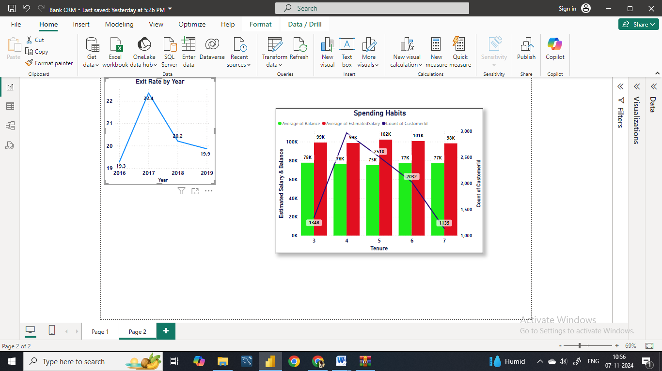

**2. Product Affinity Study: Which bank products or services are most commonly used together, and how might this influence cross-selling strategies?  
Ans.** Here we have analysed the product usage pattern to get a valuable insightsof customer behaviour and potential cross selling opportunities.

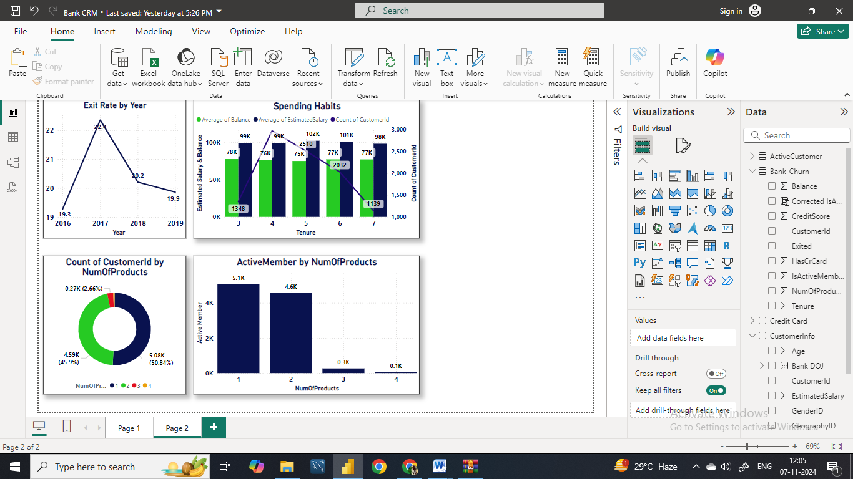

**Insights:**

* **Commonly Used Products:** We can see that the majority of customers (over 50%) use 1 or 2 products, indicating a preference for simplicity or a lack of awareness of additional offerings. Very few customers have moved for 3 or 4 products, suggesting potential interest in more comprehensive banking solutions.
* **Cross-Selling Potential:** Customers using 1 product may benefit from targeted promotions or educational campaigns highlighting complementary services, such as credit cards or savings accounts. We can see a drop in the utilization or products 3 and 4 indicating the challenges in promoting the adoption of additional services.
* **Active Customer Engagement:** The column chart illustrates the distribution of active customers across different product tiers. It is very much essential to focus cross-selling efforts on engaging active customers, as they're more likely to respond positively to offers and recommendations.
* **Optimizing Cross-Selling Strategies:** By leveraging insights from product affinity studies, banks can tailor cross-selling strategies to meet the specific needs and preferences of different customer segments. Targeted marketing campaigns, personalized recommendations, and bundled product offerings can effectively promote the adoption of additional services.

**CONCLUSION:**Understanding product affinity and customer engagement levels is critical for developing effective cross-selling strategies. By identifying commonly used products and leveraging customer insights, banks can maximize revenue opportunities as well as enhance customer satisfaction and strengthen long-term relationships.

**3. Geographic Market Trends: How do economic indicators in different geographic regions correlate with the number of active accounts and customer churn rates?**

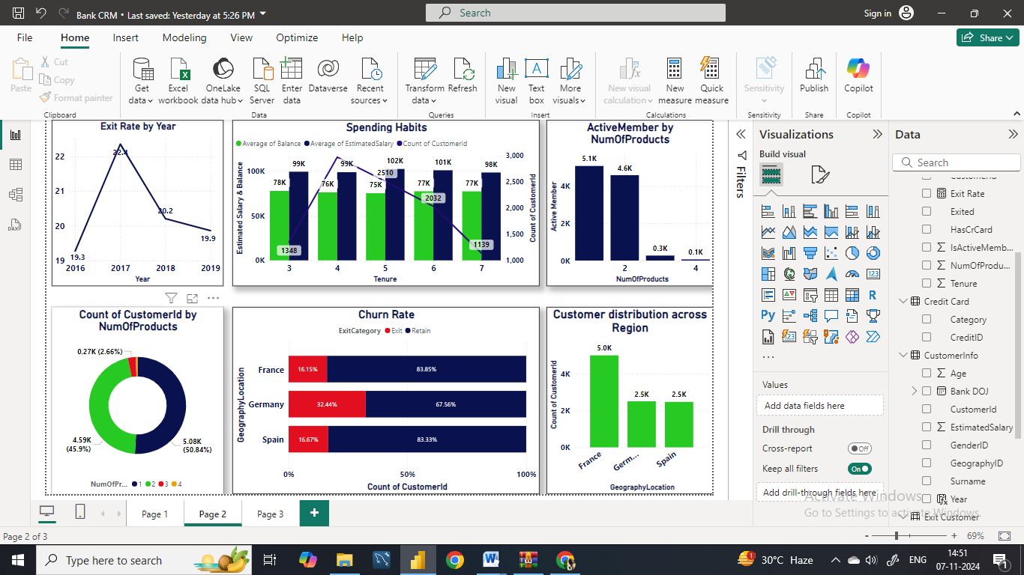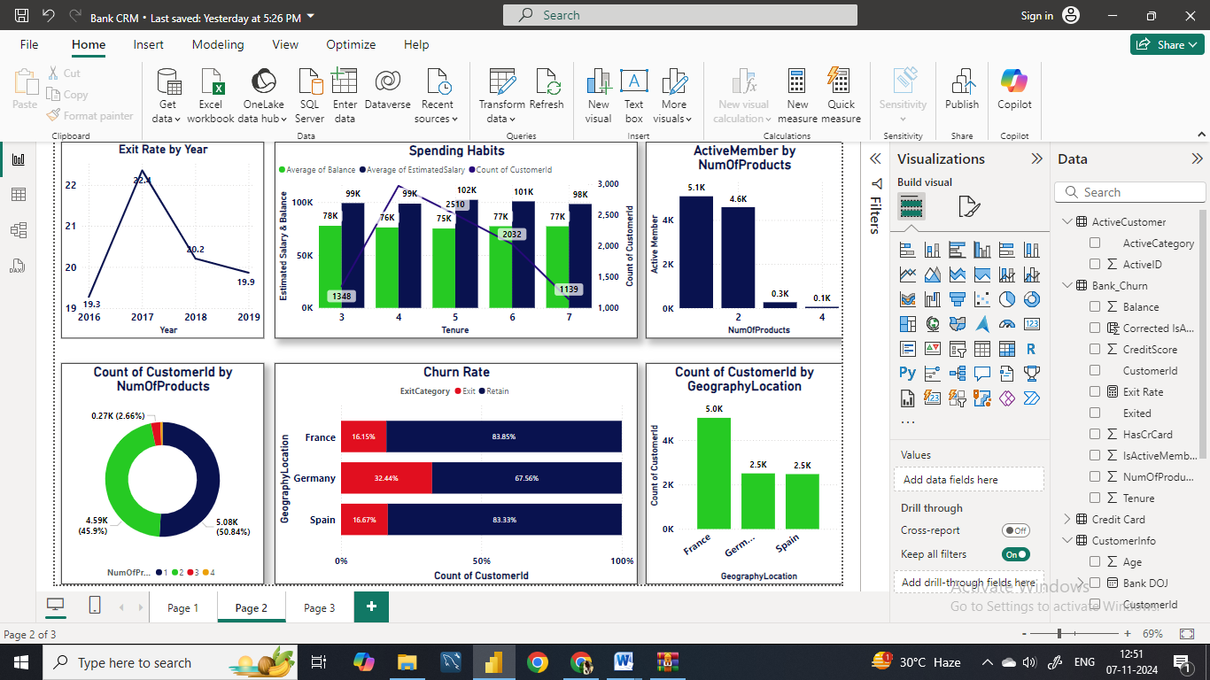

**Insights:**

**Customer distribution across regions:**  We can observe that France has the highest numbers of customers followed by Germany and Spain with varying market sizes indicating the potential opportunities for expanding business activities.

**Churn Rates:** Here we can see that the churn rate or the percentage of customers who have exited from the bank varies from region to region. Germany has the higher churn rate with 32.44% followed by Spain (16.67%) and France (16.15%).

Despite the churn rates, over 80% of the customers remain retained in various regions particularly, in France and Spain. Thus, we can analyse the factors contributing to retention rate which can used in the regions where there is higher churn rate and retention strategies are needed therefore.

**Economic Indicators:** Economic indicators such as GDP growth, unemployment rates, standard of living and household income levels may influence customer behavior and banking outcomes.

**Conclusion:** Understanding the reasons behind the churn rate in various regions will help the bank to improve the level of customer satisfactionand will also help in building various retention startegies.

**4. Risk Management Assessment: Based on customer profiles, which demographic segments appear to pose the highest financial risk to the bank, and why?  
Ans. Insights:**

The highest concentration of customers falls within the 0-20 age bucket, with around 6K customers.

Most of these customers are active members (in blue), while a smaller but significant portion is inactive.

**Inactive members:** We can see that in the age bucket of 0-20 and 20-40 the inactive member count is highest suggesting that the younger customers might be at risk of becoming inactive.

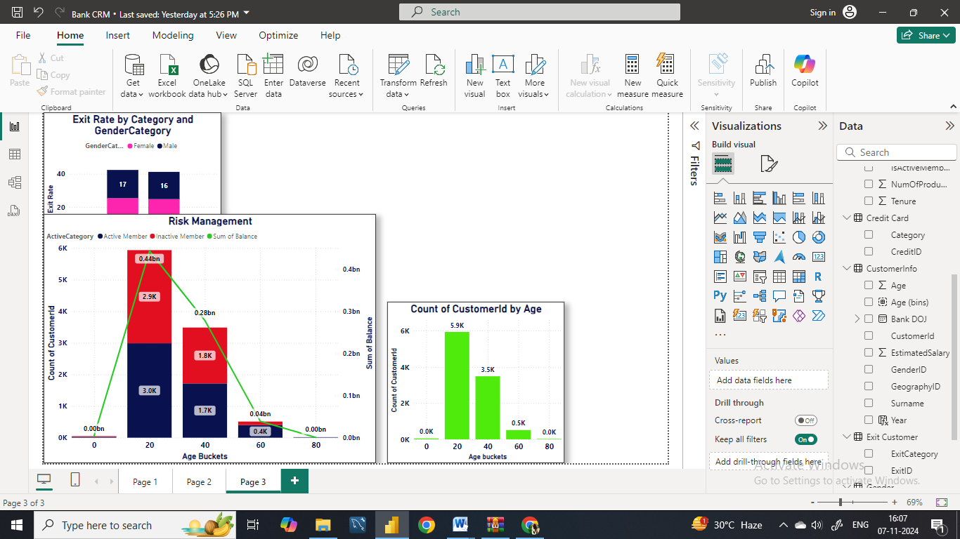

**Balance Distribution by age:** We can also see that the balance is at peak in age 0 -20 and then gradually decreased from 20-40 and much lower when it comes to older age customers.

**Risk Concentration by Age:**  We can see the younger customer (0-20) and (20-40) have the majority of banks total balance. Therefore, managing risk in these groups is very much important as they didn’t only posses the higher balance but the percentage of inactive members is also high.

While in the oldest age bucket the number of customers is low and the balance is also very low, indicating low risk in financial terms.

**Strategy:** Since the younger age customers carry the higher balance the efforts to increase engagement and customer retention among inactive younger customer can be beneficial.

With the oldest age bucket the engagement strategies may not impact the bank’s overall balance but it can create the diverse growth opportunity.

**Conclusion:**   
Overall, the chart emphasizes the importance of focusing on young customers in risk management as well as retention strategies, given their high balance and potential to become inactive.

**5. Customer Tenure Value Forecast: How would you use the available data to model and predict the lifetime (tenure) value in the bank of different customer segments?**

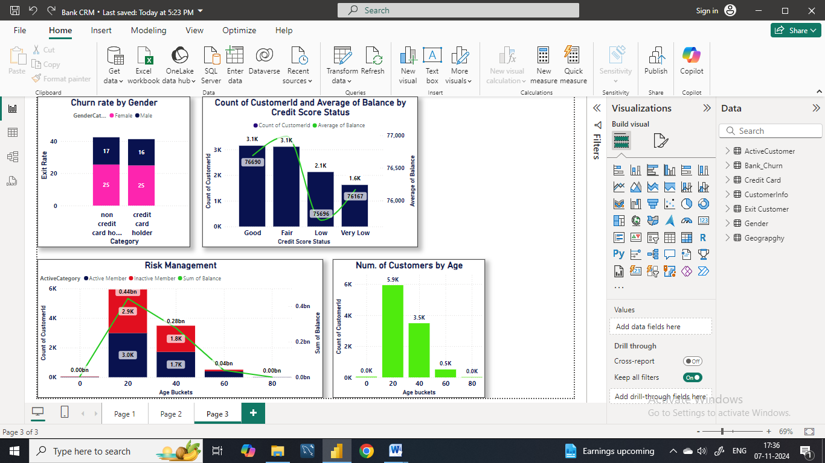 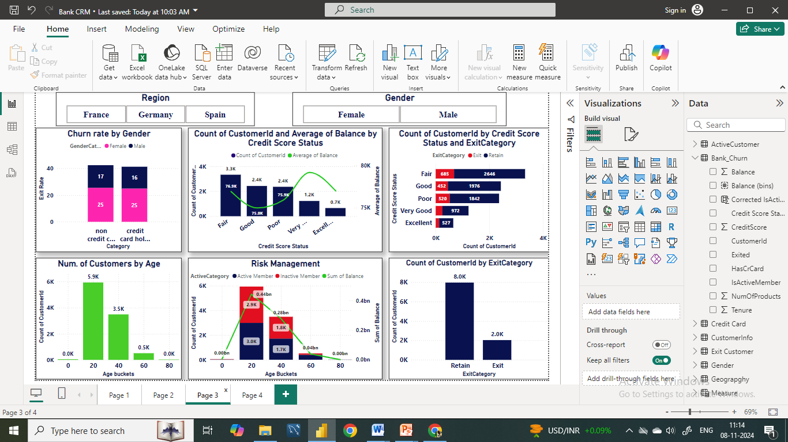

**Insights:**

**Financial stability and tenure:** We can also observe notable increase in customer count in 4th tenure but after 4th tenure there is a constant decrease in the customers count. The banks should understand the reasons for declining customer count and should up with various strategies and programmes for customer retention.

**Targeted Engagement**: The higher spending capacity of customers with 3–5 years of tenure suggests they may be a valuable segment for targeted engagement strategies. The bank could focus on retaining this group and addressing reasons why customers tend to exit or reduce engagement after 5 years.

**Customer distribution by credit score :** We can see that the Fair credit scores categories have the highest number of customers (3.3k) . This indicates that most of the customers of the bank have Good or Fair Credit score.

**Average balance by credit score:** We can see that the Very Good and excellent credit score have the higher average balance.

The average balance does not decreases with the decrease in credit score categories indicating that the customers with lower credit scores can hold sufficient balance.

Therefore it shows that the credit score is not the strong indicator of the balance size. One should consider the factors beyond the credit scores while analysing the risk.

**Strategy:** For Good and Fair categories bank should focus on enhancing the relationship and encourage the customer for more product usage.

**Conclusion:** In summary, we have seen that the large number of customers have good or fair credit scores, therefore targeted approach to engaging those in lower credit categories with high balances might help the bank manage risks more effectively and encourage overall customer retention.

**6. Marketing Campaign Effectiveness: How could you assess the impact of marketing campaigns on customer retention and acquisition within the dataset? What extra information would you need to solve this?   
Ans.** Customer Segmentation: Customers were segmented based on their credit score ranges, including Excellent, Very Good, Good, Fair and Poor. This segmentation allowed for a more targeted approach in understanding customer behavior and preferences.

Campaign Effectiveness over Time: We observed variations in exit rates over the years 2016 to 2019. In 2017, the exit rate was highest at 22.4%, followed by 2018 at 20.2%. However, the exit rate decreased slightly in 2019 to 19.9%, suggesting potential fluctuations in customer churn rates in response to marketing campaigns over time.

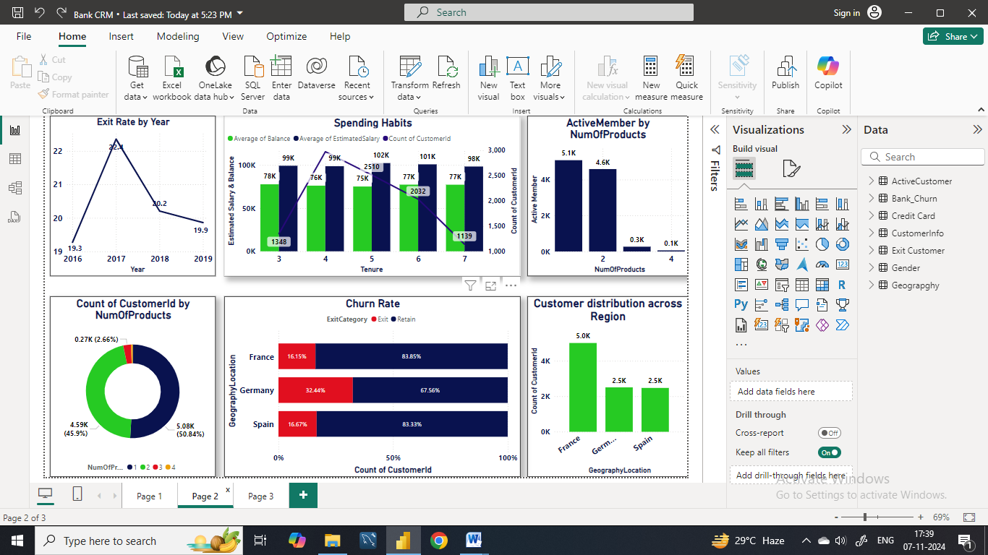 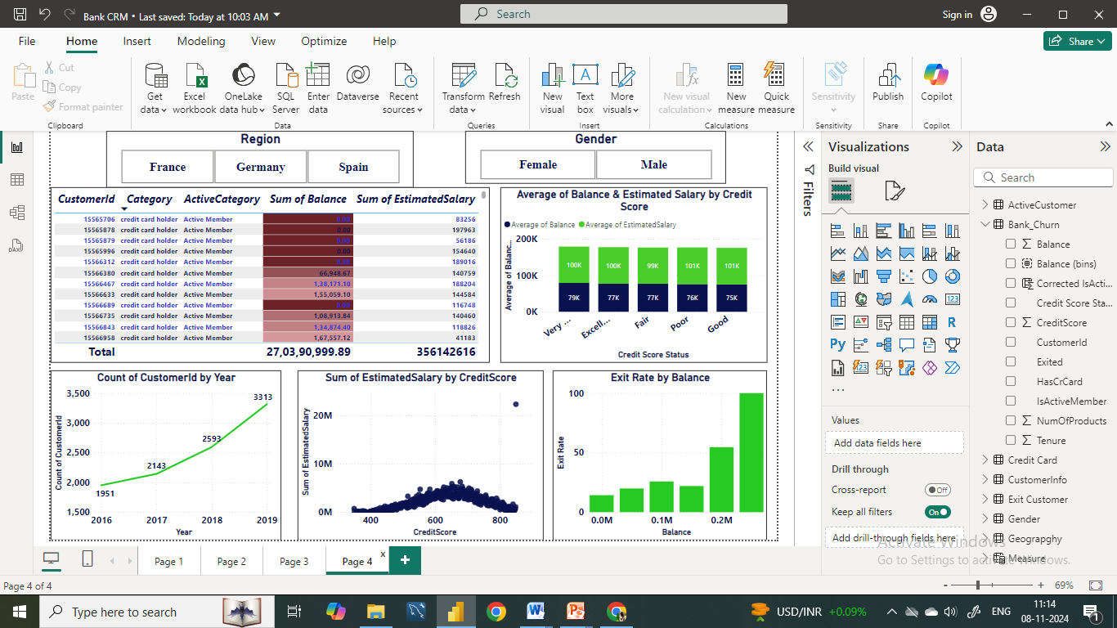 

Customer with higher credit score tend to have higher account balance and estimated salary. The customers with Very Good credit score have approximately 79 k balance and 100K estimated salary and the customers with excellent credit score have around 77k average balance and around 100k estimated salary.

**Conclusion:**  By leveraging the insights gained from the analysis of credit scores categories, financial profiles over the time period and the churn rate, the banks can take informative decision so that they can optimize their engagement and marketing strategies and can build long term customer loyalty and relationship.

**7. Customer Exit Reasons Exploration: Can you identify common characteristics or trends among customers who have exited that could explain their reasons for leaving?**

 

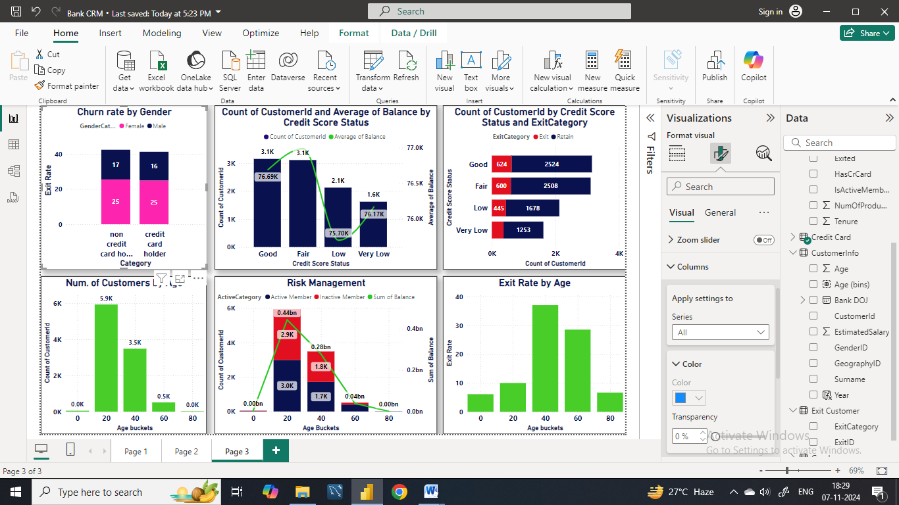 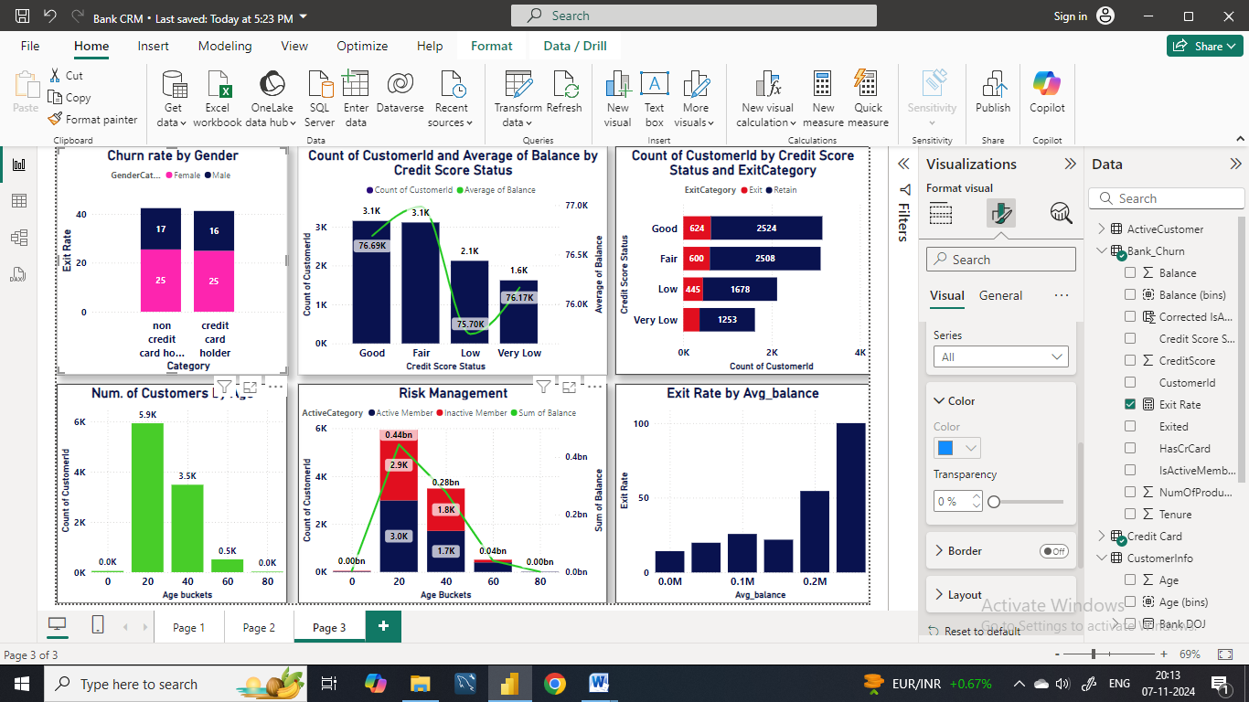 

These are some charts which shows the churn on varying basis. Here we can see the middle aged group of customers has the highest churn rate and also those who have the highest average balance are exiting the bank which indicates that bank may not be sufficient in providing the good interest also they may not have that facilities so they may be switching to other bank where they think their funds will generate an extra income or better interest.

The data suggests that customers with lower credit scores and those in certain geographic regions, particularly Germany, are more likely to churn. Additionally, while the exit rate varied from year to year, it remained relatively stable overall.

**8. Are 'Tenure', 'NumOfProducts', 'IsActiveMember', and 'EstimatedSalary' important for predicting if a customer will leave the bank?**

**Ans Importance of tenure for prediction:**This chart suggests that tenure might be a factor to consider when predicting customer churn. Customers who are newer to the bank appear to have a higher likelihood of leaving based on the distribution of exits across the tenure groups.



**Importance of NumOfProducts for prediction:** Based on this chart alone, it's difficult to say that the number of products is a strong predictor of customer churn. Here seems to be no clear trend, and the number of exiting customers fluctuates across the different product ranges.

* Customer Needs: Customers with more products might have their banking needs well-met, potentially  
  increasing their satisfaction and reducing churn.
* Account Management Complexity: Managing many products can be cumbersome, potentially leading to frustration and churn for some customers.



**Importance of IsActiveMember for prediction:** Depending on the distribution of exited customers across the active member categories, this chart can indicate the potential importance of IsActiveMember for churn prediction:

* Strong Indicator: If one category (active or inactive) has a significantly higher count of exiting customers, IsActiveMember could be a good predictor of churn.
* Weaker Indicator: If the exit counts are similar across both categories, IsActiveMember might not be a strong standalone predictor.



**Importance of EstimatedSalary for prediction:** Customer with higher credit score tend to have higher account balance and estimated salary. The customers with Very Good credit score have approximately 79 k balance and 100K estimated salary. But these factors alone can’t be used to determine the churn prediction. In the previous question we have seen that the balance is not the just the measure to determine the churn rate as.



**9.Utilize SQL queries to segment customers based on demographics and account details.  
Ans:**

**Select**

**GeographyLocation as Region,**

**Count(c.customerID) as num_of_customers,**

**Avg(balance) as avg_balance**

**from**

**bank_churn b**

**join**

**customerinfo c on b.CustomerId=c.CustomerId**

**join**

**geography g on c.GeographyID=g.GeographyID**

**group by**

**Region;**

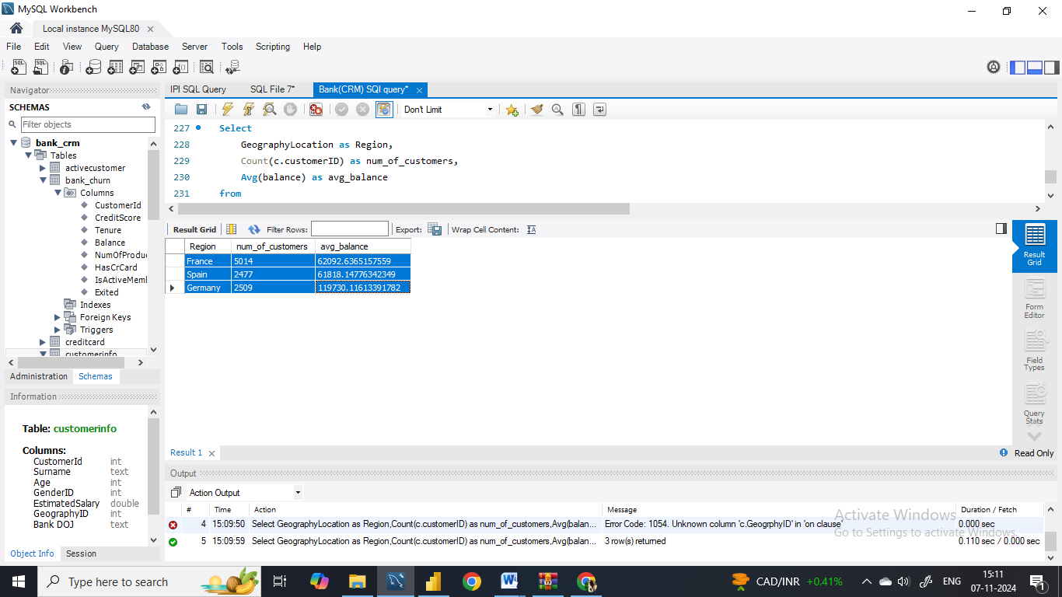

**10. How can we create a conditional formatting setup to visually highlight customers at risk of churn and to evaluate the impact of credit card rewards on customer retention?**To create a conditional formatting in Power BI to highlight customers at risk of churn and evaluate the impact of credit card rewards on customer retention, follow these steps:

* First we have to create a table visualization in Power BI.
* Then add the following fields to the table: CustomerId Category (indicating whether the customer has a credit card or not), ActiveCategory (filtered to show only "Active Member" records), Sum of Balance & Sum of EstimatedSalary.
* For the "Sum of Balance" columns, apply conditional formatting to highlight values based on specific conditions.
* To highlight customers at risk of churn, I have used magenta color formatting for customers with low account balances.

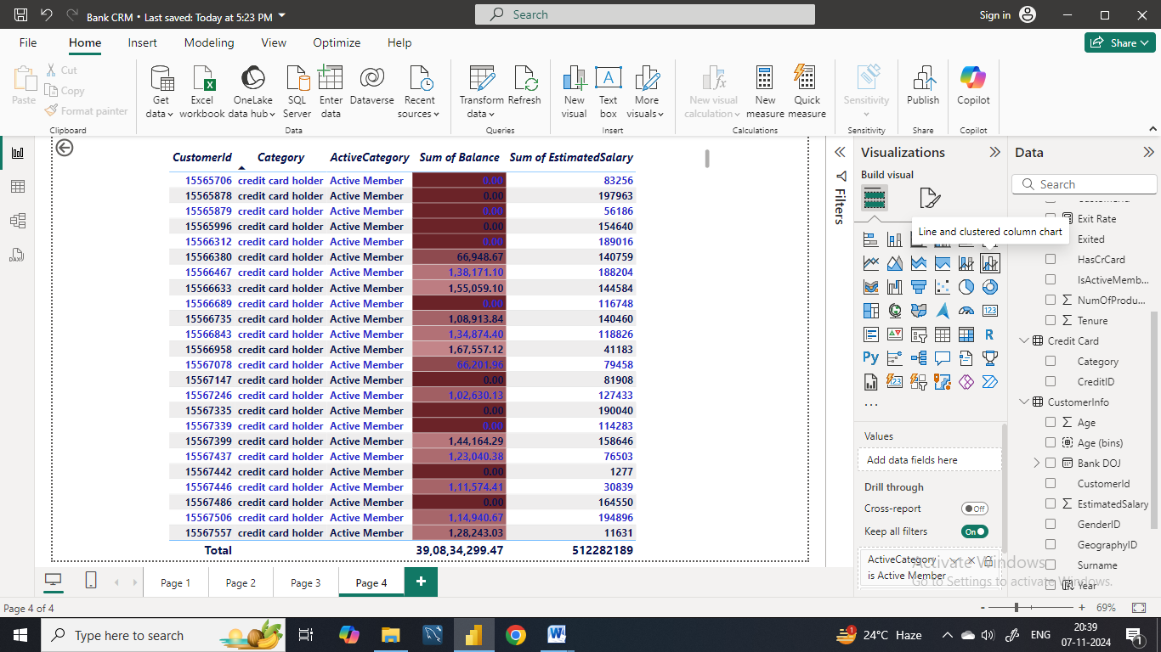

**11. What is the current churn rate per year and overall as well in the bank? Can you suggest some insights to the bank about which kind of customers are more likely to churn and what different strategies can be used to decrease the churn rate?**

 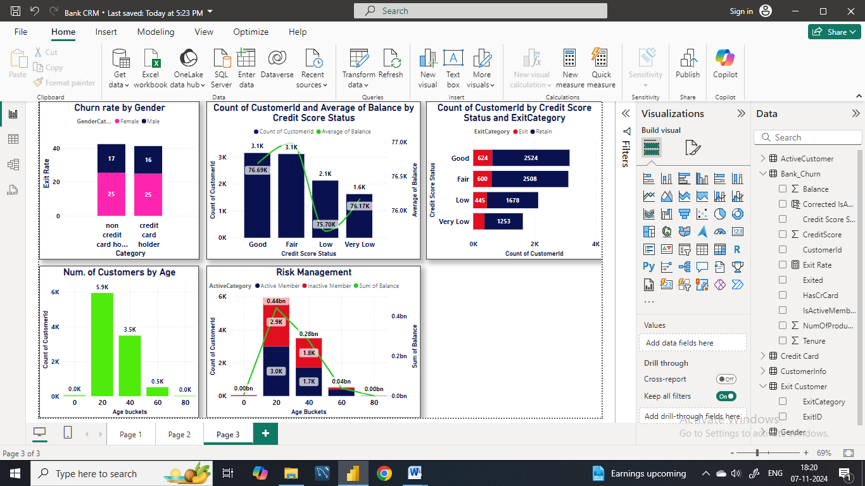

**Insights:**

**Credit Score Range Analysis**: Customers with lower credit scores, particularly in the Bad and Poor categories, were more likely to exit the bank. This trend suggests that customers facing financial challenges or with a history of credit issues may be more inclined to leave the bank.

**Temporal Analysis:** The exit rate fluctuated over the years, with the highest rate observed in 2017 and the lowest in 2019. Despite the fluctuations, the overall exit rate remained relatively consistent, averaging at 20.45% over the four-year period.

**Conclusion**  
The data suggests that customers with lower credit scores and those in certain geographic regions, particularly Germany, are more likely to churn. Additionally, while the exit rate varied from year to year, it remained relatively stable overall.



**Recommendations:**

**Segmentation and Targeted Marketing:** The bank should use the customer segmentation techniques to identify high-risk segments, such as customers with lower credit scores or those in regions with higher churn rates. Implement targeted marketing campaigns to address their needs and improve retention rates.

**Regional Strategies:** Implement strategies tailored to address specific challenges in high-churn regions, such as improving customer service, expanding product offerings, or partnering with local organizations to better understand and meet customer needs.

**Customer Engagement Programs:** Bank should develop initiatives to enhance customer engagement and loyalty, such as personalized offers, rewards programs, and proactive communication channels. Engaged customers are likely considered to remain resulting in decreasing churn rates.

**Continuous Monitoring:** The bank should regularly monitor churn rates and customer feedback to identify emerging trends and adjust retention strategies according to the needs. By staying proactive and responsive to customer needs, the bank can effectively reduce churn and can enhance overall customer satisfaction.

**Credit Score Improvement:** Offer financial education resources and products designed to help customers improve their credit scores. Improving financial literacy and providing access to credit-building tools can help mitigate churn among customers with lower credit scores.

**12. Create a dashboard incorporating all the KPIs and visualization-related metrics. Use a slicer in order to assist in selection in the dashboard.**

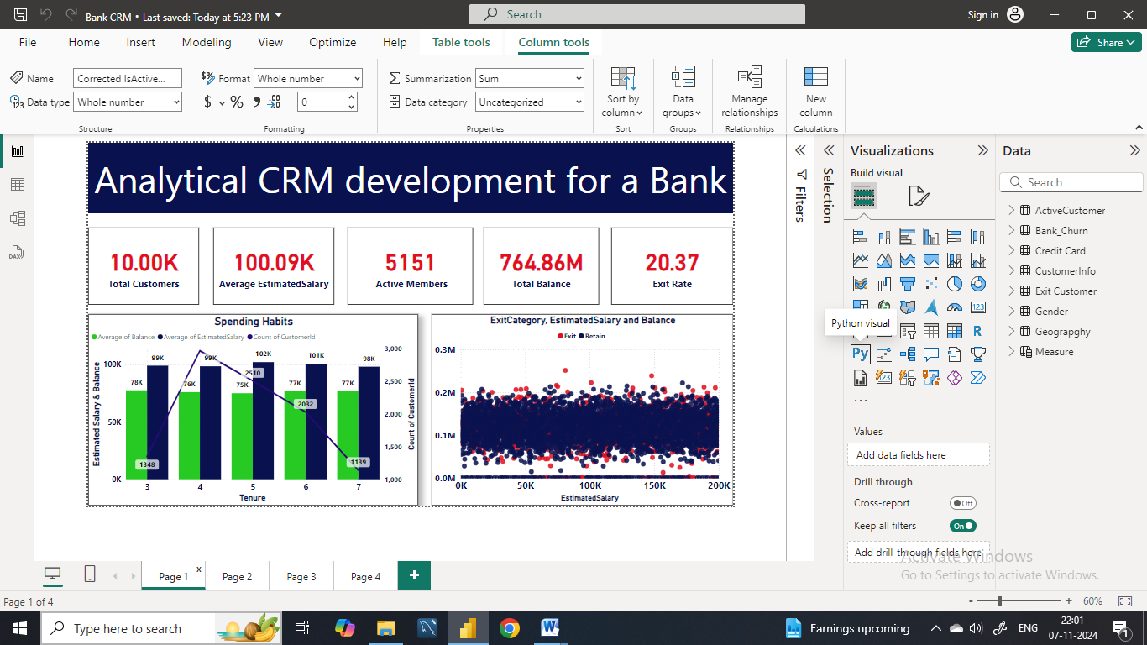

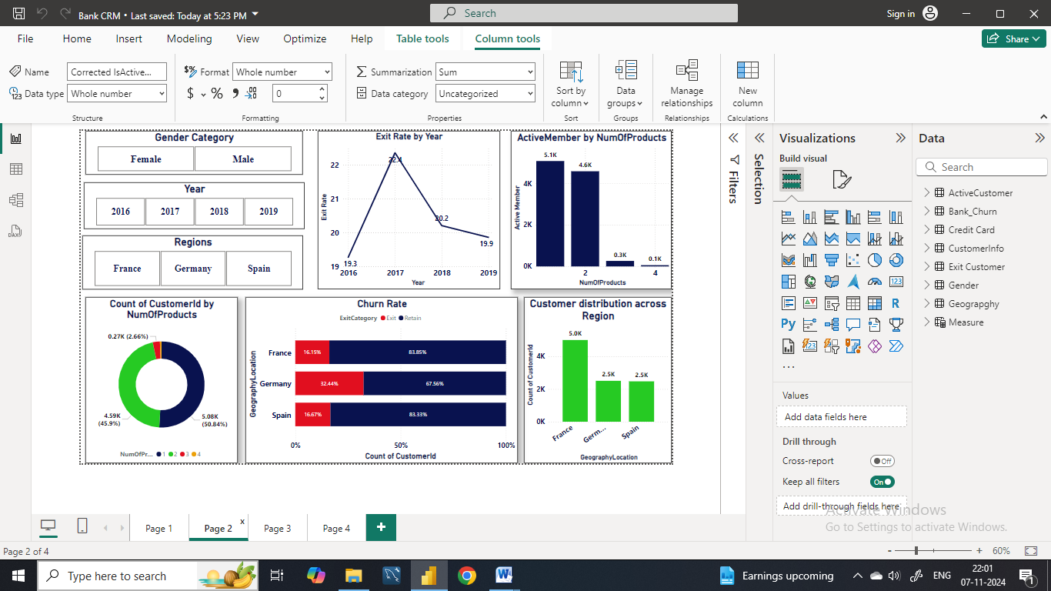





**13. How would you approach this problem, if the objective and subjective questions weren't given?  
Ans.** We can effectively approach a problem by following a process that involves generating hypotheses and asking your own questions, and deriving insights. Here's a breakdown of this approach:

First we have to make the assumptions about the data or problem. These hypotheses can be based on your understanding of the domain, industry best practices, or even initial observations of the data.   
  
Then based on our hypotheses, we will then formulate questions that can be answered using the available data.   
1) Does the balance and estimated salary influence the churn rate?  
2) Do the Age or region is connected with the churn rate or had any effect on bank churn rates?  
3) Is there any correlation between the credit card scores or the churn rate?

**Marketing Campaign Analysis:**

1) Which marketing channels we should choose that can be most effective at reaching target audiences?   
2) Is there any correlation between advertisement expenditure and number of customers over the years?  
3) What is the effect of campaign marketing?   
4) Is there any relation between the advertisement expenditure and the churn rate?

After this we perform various calculation and visualization to answer those formulated questions.  
  
**Insights and Recommendations:** Based on our analysis, we will draw insights that can lead to decision-making. These insights could relate to customer behavior, marketing strategies, product development, or other areas relevant to the problem.

**14. In the “Bank_Churn” table how can you modify the name of the “HasCrCard” column to “Has_creditcard”?**

**Ans. SQL Query to change the column name:**

**Alter table bank_churn**

**Change Column HasCrCard Has_creditcard int;**